EXPERIMENT NO. 5
Mark Sheet Processing System using Zoho Creator (SaaS)

Aim
To develop a cloud-based Mark Sheet Processing System using Zoho Creator for managing student marks and demonstrating Software as a Service (SaaS).

Objective
• Create a cloud-based mark sheet application.
• Store student and subject details.
• Calculate total, average, percentage and rank.
• Generate reports.

Software Requirements
• Zoho Creator
• Google Chrome
• Internet Connection
• Deluge Script (optional)

Theory
The Mark Sheet Processing System is a cloud-based application that stores student details and subject marks. It automatically processes academic results by calculating the total, average, percentage and rank. Zoho Creator provides a SaaS platform for secure data storage and report generation.

Fields Used
Student Name, Register Number, Tamil, English, Mathematics, Science, Social Science, Total, Average, Percentage, Rank.

Algorithm
1. Start
2. Open the Mark Sheet form.
3. Enter student details and subject marks.
4. Calculate Total.
5. Calculate Average.
6. Calculate Percentage.
7. Assign Rank.
8. Save the record.
9. Generate report.
10. Stop.

Procedure
1. Login to Zoho Creator.
2. Create the Mark Sheet Processing System application.
3. Design the form with all required fields.
4. Enter sample records.
5. Save the records.
6. Create a report.
7. Verify the output.

Observation
• Student details were entered successfully.
• Subject marks were stored correctly.
• Total, average and percentage were generated.
• Rank was displayed.
• Reports displayed all student records.
• The application worked correctly.

Result
The Mark Sheet Processing System was successfully implemented using Zoho Creator. Student records were stored and reports were generated successfully.

Conclusion
The experiment demonstrated the implementation of a cloud-based Mark Sheet Processing System using Zoho Creator.

Output Screenshots
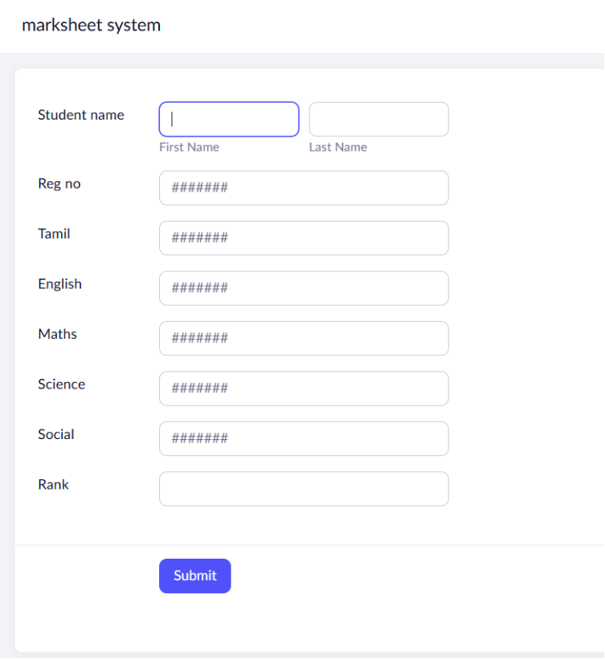
Figure 1: Mark Sheet Entry Form
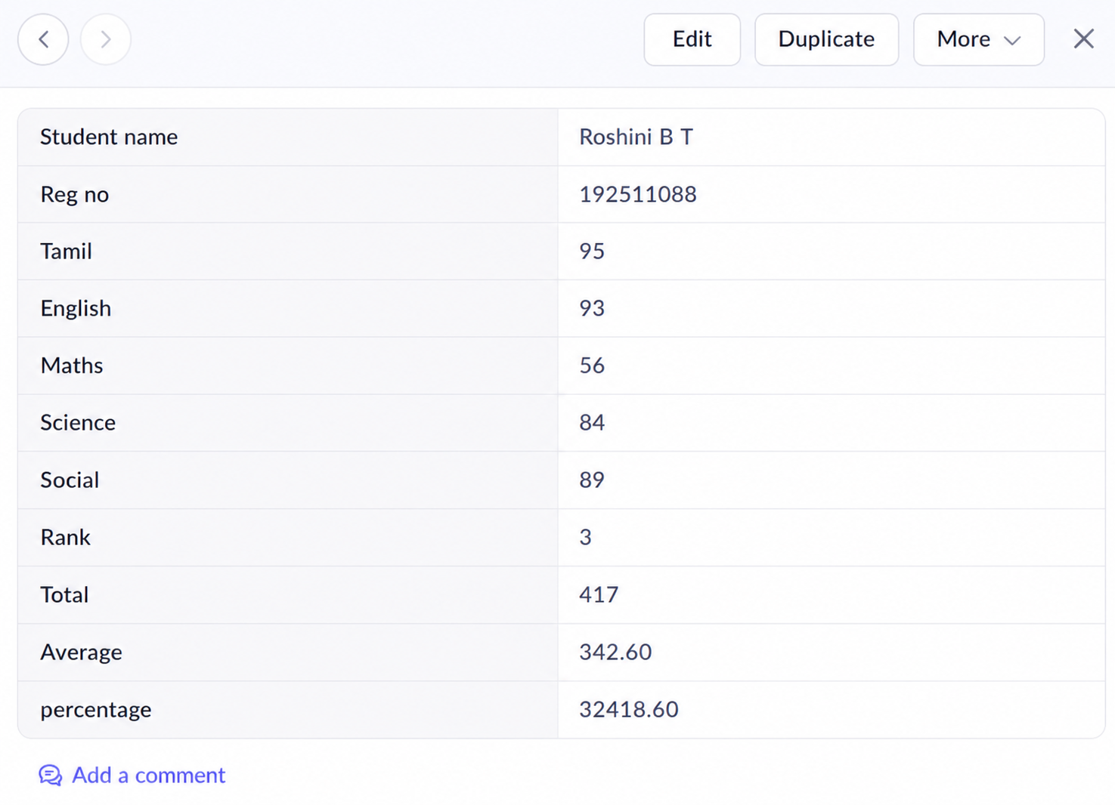
Figure 2: Individual Student Record
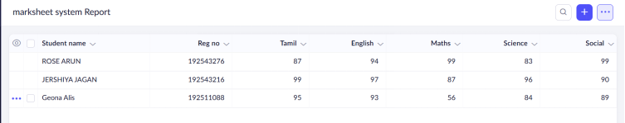
Figure 3: Mark Sheet Report

